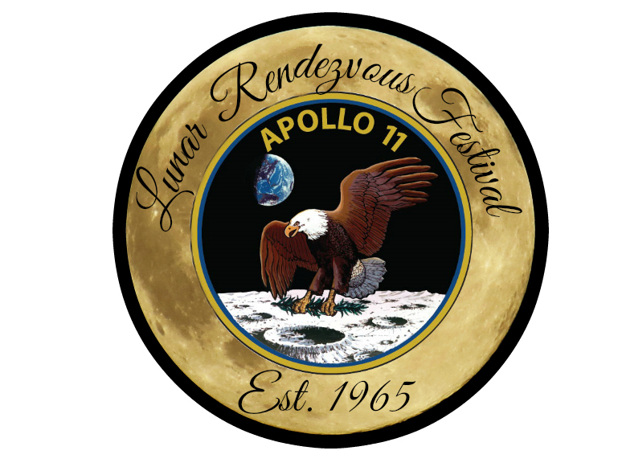

Welcome to the 56th Annual Lunar Rendezvous Festival! The first Lunar Rendezvous Festival was held in 1965 to celebrate the rendezvous of Gemini IV and Gemini V in space and to preserve the history and accomplishments in the space sciences area. Over the years, the Festival has grown beyond its founder’s imagination. Each year, hundreds of volunteers work together to foster community spirit and raise funds to benefit the Bay Area. The proceeds from the Lunar Rendezvous Festival are used to award college scholarships and provide program funding for local non-profit organizations in our community.

Some time ago, an idea was brought forward to include the outstanding youth of the Bay Area, and thus the Festival Court comprised of princesses and lieutenants came into existence. Years later, the Festival Court was expanded to also include Little Ladies-in-Waiting and Pages. Including these younger children was a way to recognize those parents who had been active in the Bay Area community through volunteer work.

The selection process for the 2021 Lunar Rendezvous Festival has begun. You are invited to submit an application on behalf of your child for consideration. All applications are reviewed by an independent committee which will select girls and boys to serve as Little Ladies-in-Waiting and Pages. Applicants must be at least seven and no more than ten years of age on June 1, 2021.

A handbook and application are attached to this letter. Please read the handbook carefully, as your completed application signifies your understanding and compliance with the information presented. We look forward to yet another wonderful Lunar Rendezvous Festival and hope you will join us.

Warm Regards,

Penny Brockway
2020/2021 Lunar Rendezvous Festival
General Chairman
Lunar Rendezvous Festival 2021
Little Ladies-in-Waiting and Pages Handbook

What is The Lunar Rendezvous Festival?

The Lunar Rendezvous Festival began in 1965 as a 501(c)(3), non-profit organization formed to preserve the history and accomplishments in the space sciences made in the Bay Area. Each year hundreds of volunteers join together to promote charity, celebrate, and honor our community.

The official Lunar Rendezvous Festival web site, www.lunarrendezvous.org is a great source of information. Before you submit your application, please take some time to visit this web site. There you will learn about the history of Lunar Rendezvous and how the Festival has developed over the years. The organization of Lunar Rendezvous is also explained, from the Board of Directors to the Event Chairmen. Other important information on the web site includes: a calendar of events, the list of court members and festival sponsors, photography information, and forms that can be downloaded.

The Lunar Rendezvous Festival consists of a “Court” that is comprised of outstanding 11th-grade girls and boys from our area, as well as a group of younger children known as Little Ladies-in-Waiting and Pages. The Little Ladies-in-Waiting and Pages are girls and boys, from 7 to 9 years of age, who add a special element to the Festival while allowing them an opportunity to contribute to our community at a very young age.

Before completing the attached application, please review the following information carefully. The completed application must be emailed to lunarrendezvousfestivalchair@gmail.com no later than January 31, 2021. In addition, a $30 Application Fee must be submitted at www.lunarrendezvous.org under the Get Tickets section. You will receive an email confirmation upon receipt of application. If you have not received confirmation within 48 hours, please contact the General Chairman at lunarrendezvousfestivalchair@gmail.com.

By filling out and signing the application, parents are indicating that they have read and understand all the information contained in this handbook.

The Selection and Notification Process

An independent selection committee, appointed by the Lunar Rendezvous Board of Directors, will review all applications and select the Little Ladies-in-Waiting and Pages for the 2021 Festival Court. All applicants will be notified on or about March 1, 2021.

My Child is on the Court – What’s next?
- If your child is selected and you would like for them to participate as a little lady in waiting or a page, please sign and return the acceptance form you receive in the mail no later than March 15, 2021. Please make sure to read and fill out this acceptance form completely. Enclose a non-refundable fee of $150. This fee covers the cost of the following:
  - Lunar Rendezvous Festival Little Lady-in-Waiting or Page sash
  - Lunar Rendezvous Festival Polo Shirt

In addition, every court member must have a sponsor. Festival Sponsors include individuals and businesses located in our area. As a Festival Sponsor, individuals and/or businesses will be featured on our website and in our event programs, and may receive advertising in community newspapers. The sponsor fee is $300.00. The sponsor fee covers the following items:
  - Court member’s ticket to the Fashion Show and Coronation Ball
  - Flowers presented at the Fashion Show and the Coronation Ball
  - Photography Sitting Fee (Formal Headshot)

Included in your acceptance letter will be the date, time and place for our first orientation meeting for parents. It is essential that at least one parent attend this meeting.

As a Little Lady-in-Waiting or a Page, your child can expect a summer filled with festival events, philanthropy, fellowship, friends, family and fun. There will be Little Ladies-in-Waiting and Pages Chairmen at your disposal. They will guide you during the Festival and ensure that all information is being successfully communicated. Current e-mail addresses are an absolute must!

Calendar of Events
Please refer to the web site, www.lunarrendezvous.org for the most current calendar of events. When the calendar of events is finalized a hard copy will be distributed to all court members and their parents.
Since the Little Ladies-in-Waiting and Pages are such a special part of the Festival Court, the following events are mandatory, and all Little Ladies-in-Waiting and Pages are expected to attend these events. To avoid any conflicts, please check your calendar with regard to these specific dates before you submit your application. The heaviest concentration of events is during the last week of July 2020.

Kick-Off Sunday, April 18, 2021, 2:00 p.m.
Presentation of all 2021 Court Members
and the 2020 Distribution of Funds
Location: TBD

Sunset Service – Sunday, July 18, 2021, 6:00 pm
Location: TBD

Monday, July 19, 2021, 6:00 p.m.
Fashion Show Rehearsal for Little Ladies-in-Waiting and Pages
Location: San Luis Convention Center, Galveston, Texas

Tuesday, July 20, 2021, 10:30 a.m.
Fashion Show for Princesses and Lieutenants
Little Ladies-in-Waiting and Pages
Location: San Luis Convention Center, Galveston, TX

Friday, July 23, 2021, 7:00 a.m.
Official Formal Group Photograph for Princesses and Lieutenants
Little Ladies-in-Waiting and Pages
Location: Space Center Houston

Saturday, July 24, 2021, 4:00 p.m.
Rehearsal for Coronation Ball – Little Ladies-in-Waiting, Pages and Presenters
Location: San Luis Convention Center, Galveston, TX
Little Ladies-in-Waiting are presented by their fathers, while Pages are presented by their mothers.

Saturday, July 24, 2021, 5:00 p.m.
Coronation Ball – Princesses and Lieutenants,
Little Ladies-in-Waiting, Pages, and Presenters
Location: San Luis Convention Center, Galveston, TX

The Coronation Ball is a black-tie event. Little Ladies-in-Waiting are required to wear white, floor-length, formal dresses. More information will be given to you at the orientation meeting about ordering your Little Lady’s dress. Pages are required to wear a tuxedo consisting of a white jacket, black pants, black tie and cummerbund. This attire is also required for the formal group photo taken on Friday, July 23, 2021.

At the Coronation Ball, male presenters are required to wear a tuxedo consisting of a black jacket, black pants, black tie and cummerbund. Female presenters should wear a long gown.

The Lunar Rendezvous Festival is a non-profit 501(c)(3) organization; therefore, our goal is to return as much money to the community as possible. Thus, some of the mandatory events listed above require an admission fee. The Little Ladies-in-Waiting, Pages, parents, and other family members must purchase tickets to attend the events. Some of the ticket prices are listed below:

Kick-Off Party No Admission Fee
Fashion Show Ticket Prices range from $100 - $150 per person
Coronation Ball $150 per person

Thank you for your interest in the Lunar Rendezvous Festival 2021. Should you have any questions or need clarification on any of the above information, please contact Festival Chairman, Penny Brockway at 281-684-6842 or lunarrendezvousfestivalchair@gmail.com

Please complete the following Court Application. The completed application must be EMAILED to lunarrendezvousfestivalchair@gmail.com by January 31, 2021. The $30 application fee must also be submitted by this date at www.lunarrendezvous.org. You will receive an email confirmation upon receipt of application. If you have not received confirmation within 48 hours, please contact the General Chairmen at lunarrendezvousfestivalchair@gmail.com.

APPLICATION MUST BE EMAILED AND APPLICATIN FEE SUBMITTED NO LATER THAN JANUARY 31, 2021.

2021 Lunar Rendezvous Festival
Court Selection Profile Application
Little Lady-in-Waiting Page
This information is for review in the selection process. There are NO guarantees as due to space availability, only a certain number of children are accepted as defined by the guidelines of the Lunar Rendezvous Festival Operational Procedures. CHILDREN MUST BE AT LEAST SEVEN (7) AND NO MORE THAN (10) YEARS OF AGE ON JUNE 1ST, 2021.
Child’s First & Middle Name Last Name _______________
List child’s name as you would like it listed in Lunar Rendezvous Festival printed materials
Name Child goes by
Child’s Birthdate Age on June 1, 2021 .
Child’s School
Grade for 2021-2022 School Year
Child’s Activities: ___________________________________________________________________
______________________________________________________________________________
______________________________________________________________________________
PARENTS
Mother’s Name
Address City/Zip
Email Home Phone
Work # Cell
Mother’s Community Activities (attach separate sheet, if necessary)

Stepfather’s Name (if applicable) Work Number ______
Community Activities:

APPLICATION MUST BE EMAILED AND APPLICATION FEE SUBMITTED NO LATER THAN JANUARY 31, 2021.

2021 Lunar Rendezvous Festival
Court Selection Profile Application
Page 2
Father’s Name
Address City/Zip
Email Home Phone
Work # Cell
Father’s Community Activities (attach separate sheet, if necessary)

Stepmother’s Name (if applicable) Work Number ___________

Community Activities:

Has anyone in the family (parents, siblings, grandparents) previously been involved in the Lunar Rendezvous Festival? Yes No
If yes, who was involved (names please) and what was their involvement?

What would you like your child to get out of this experience?

Signed
Parent / Guardian

APPLICATION MUST BE EMAILED AND APPLICATION FEE SUBMITTED NO LATER THAN JANUARY 31, 2021.

2021 Lunar Rendezvous Festival
Court Selection Profile Application
Page 3
Handbook Acknowledgement
I have read the attached Court Handbook, including the attendance requirements, and fully understand the information presented.
Parent/Guardian
Signature* Date

*Electronic signatures will not be accepted

Thank you for your interest! Upon completion of a confidential selection committee review, you will be notified of the decision on or before March 1, 2021.

APPLICATION MUST BE EMAILED AND APPLICATION FEE SUBMITTED
NO LATER THAN JANUARY 31, 2021.

